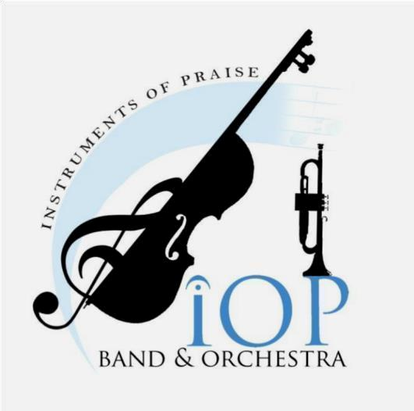
INSTRUMENTS OF PRAISE HOME SCHOOL CONCERT BANDS, STRING
ORCHESTRAS, & FULL HONOR ORCHESTRAS
Paul Sommer – Band and Orchestra Director
832-813-8901 www.instrumentsofpraise.org

Meeting at THREE locations for the Fall 2025 and Spring 2026 semesters

Mr. Sommer will be directing three different levels of bands – beginner, intermediate, and advanced band
for students that are 9 years old and up. He will be directing three levels of string orchestra – intermediate
(at least one year experience necessary) advanced strings orchestra and full honor orchestra. The instruments that we have in the beginner bands are flutes, clarinets, alto saxophones, trumpets, trombones and bell kits. Auditions will be required to participate in the full honor orchestra and the advanced string orchestra. The honor full orchestra and advanced string orchestra is also open to students who have graduated from high school and are not older than twenty-two years of age. The Fall 2025 semester will begin in August and the Spring 2026 semester will begin in January, with classes meeting once a week for fifteen weeks each semester. The beginner, intermediate and advanced band, and string orchestra classes are fifty minutes long. The full honor orchestra classes are sixty minutes long.

MONDAY-
Spring - North Central Church - 25130 Aldine Westfield -Spring, TX 77373
Beginner Band – 12:30-1:20 P.M., Intermediate Band - 1:30 - 2:20 P.M., Advanced Band 2:30 – 3:20 P.M., Intermediate String Orchestra – 3:30 - 4:20 P.M., Advanced String Orchestra – 4:30 - 5:20 P.M., Full Honor Orchestra - 5:30-6:30 P.M.

The Fall Semester MONDAY class dates are: 1) Aug. 18 2) Aug. 25 3) Sept. 8 4) Sept. 15 5) Sept. 22 6) Sept. 29
7) Oct. 6 8) Oct. 13 9) Oct. 20 10) Oct. 27 11) Nov. 3 12) Nov. 10 13) Nov. 17 14) Nov. 24 15) Dec.1

The Spring Semester MONDAY class dates are: 1) Jan. 12 2) Jan. 19 3) Jan. 26 4) Feb. 2 5) Feb. 9 6) Feb. 16
7) Feb. 23 8) Mar. 2 9) Mar. 16 10) Mar. 23 11) Mar. 30 12) Apr.13 13) Apr. 20 14) Apr. 27 15) May 4

TURN OVER

TUESDAY-
NORTHWEST HOUSTON- Windwood Presbyterian Church - 10555 Spring Cypress Road – Houston, TX 77070
Intermediate Band 2:00-2:50, Advanced Band 3:00-3:50, Beginner Band 4:00-4:50

The Fall Semester TUESDAY class dates are: 1) Aug. 19 2) Aug 26 3) Sept. 2 4) Sept. 9 5) Sept. 16 6) Sept. 23
7) Sept. 30 8) Oct. 7 9) Oct. 14 10) Oct. 21 11) Oct. 28 12) Nov. 4 13) Nov. 11 14) Nov. 18 15) Dec. 2

The Spring Semester TUESDAY class dates are: 1) Jan. 13 2) Jan. 20 3) Jan. 27 4) Feb. 3 5) Feb. 10 6) Feb. 17
7) Feb. 24 8) Mar. 3 9) Mar. 17 10) Mar. 24 11) Mar. 31 12) Apr. 14 13) Apr.21 14) Apr. 28 15) May 5

The cost per student to be in any level of band or orchestra class for the EACH SEMESTER is $295. The cost for the second child in each family in any level of band or orchestra class is $275 for each semester. The cost for each additional sibling in each family in any level of band or orchestra class is $245 for each semester. If a student wants to play two instruments or wants to attend two classes per week and signs up for two band and/or orchestra classes, the cost of the second band or orchestra class is $120.00 for each semester. (If necessary, you may pay in two or three payments per semester). The semester fees must be paid no matter when your student starts or stops attending the band, or orchestra classes. You must pay for the days your student is absent from class. There will be no refunds whatsoever. All students are expected to enroll for both the Fall 2025 and Spring 2026 semesters. If any band or orchestra student does not re-enroll for the Spring 2026 semester, a drop fee of $ 100 per student will be charged. All band and orchestra students must provide their own instruments, workbooks and music stands and be responsible for the maintenance of their instruments. Please note that all Christian, private and public school students that are in any of the homeschool bands or orchestra classes listed above are responsible to attend the classes regardless of school schedules or conflicts that may arise and all the rules listed above apply to all students. Please visit www.instrumentsofpraise.org for all rules and guidelines and to REGISTER for the classes. If you have any questions regarding the INSTRUMENTS OF PRAISE home school concert band, string orchestra classes or the honor full orchestra, please e-mail Paulsommer@att.net or call 832-813-8901.
Paul Sommer – Band and Orchestra Director

